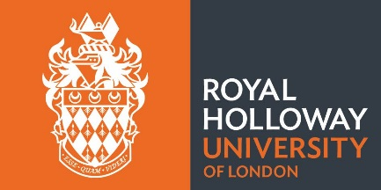
Department of Geography
Departmental Master’s Scholarship Application

To be considered for a Departmental Master’s Scholarship, please complete this form and return it by email to the Director of the Master’s-degree programme to which you have applied. The deadline is 6 September 2019. Scholarships are awarded (up to a maximum value of £1,000) at the discretion of the programme director.

First name
Surname

Master’s-degree programme to which you have applied

In the box below, please explain (in a maximum of 250 words), why you think you should receive a Departmental Master’s Scholarship.

