Royal Holloway
Geography for Schools
Lecture Series

Understanding past changes in Drylands Activity
Author: Prof Ian Candy
Case study: The “Green-Sahara” and the African Humid-Period

A-Level Syllabus:
- AQA Hot desert systems and landscapes: Deserts as natural systems; Desertification (past and future)
- OCR Dryland landscapes: How can dryland landscapes be viewed as systems? How do dryland landforms evolve over time as climate changes?

Introduction
Dryland regions are not static they change over time. Regions that today are considered hyper-arid, are un-vegetated and contain nothing but a sea of shifting sand were once lush grasslands with flowing rivers, extensive lakes and populations of hippos and crocodiles. In contrast, areas that are now savannah or even tropical woodlands were once Drylands and characterised by arid sand dune landforms. How do scientists know this? And how can the timing of the past expansions and contraction of the World’s deserts be reconstructed? Unsurprisingly a lot of the evidence for this comes from the Drylands themselves. For decades, if not centuries, geographers and archaeologists have found evidence, in regions such as the Sahara, for sediments deposited in what were once extensive lake systems and of fossils of water demanding species, from hippos and crocodiles to snails and microscopic organisms. The pain-staking analysis of this evidence has been patched together to produce a history of changing desert conditions.

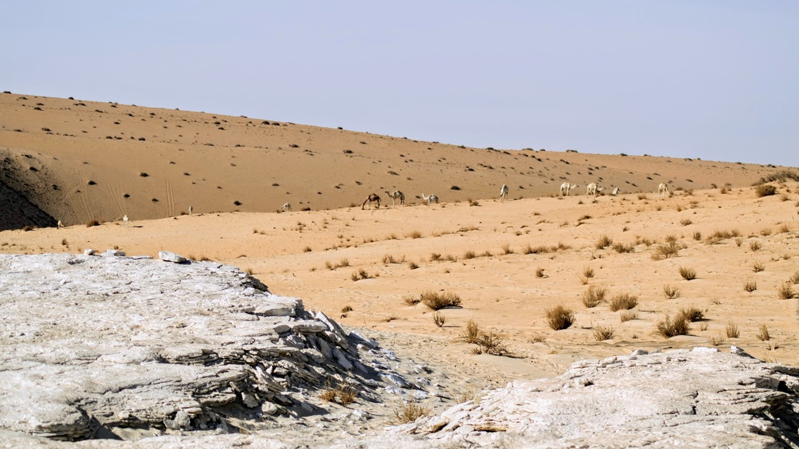
Figure 1 – A photo from the Arabian Desert. This shows, in the background, the large Aeolian sand dunes the typify desert regions. In the foreground are beds of white sediment that were deposited on the bed of a large permanent lake which was many metres deep (Photo Klint Janulis)
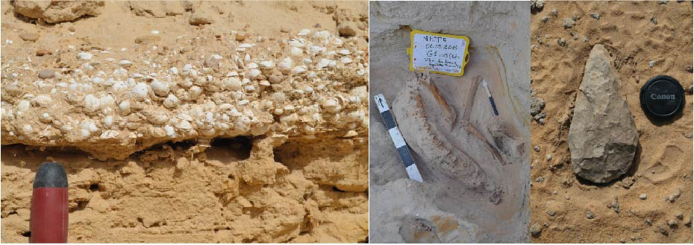
Figure 2 – Evidence for increased water availability in regions which are now hyper-arid/arid (from left to right) 1 – lake shorelines in southern Tunisian characterised by rich accumulations of freshwater molluscs, indicating the presence of an extensive lake basin, 2 – fossil mammal (antelope) remains from shoreline sediments in southern Tunisia, indicating the presence of a lush savannah grassland and 3 – a Pre-histoic hand-axe form the Arabian desert indicating a landscape with enough water availability to sustain human populations.

Evidence of Deserts from the Oceans?
Although Dryland regions contain a rich record of past climate change this evidence is frequently fragmentary and incomplete. This is because the processes that operate in desert regions are frequently highly erosive. The strong winds that operate in these localities scour sediments away and sand-blast fossils until they are destroyed. Equally, whilst river flow is very rare in these regions when storms do occur the resulting floodwaters strip away large amounts of the landscape. Consequently, we need to combine the evidence for changing climate in desert regions than we find on the land surface itself with more complete records that are found elsewhere in the world.

In order to try and produce more complete records of past climate change many scientists have turned to the study of the sediments that accumulate on the floor of the deep oceans, such as the Atlantic. Sediments that stack up on the ocean floor produce relatively complete and continuous records of changing processes. This is because, unlike desert regions, very few erosional process operate on the ocean floor, here sediments stack up slowly overtime in an undisturbed fashion. Microscopic animals that die in the water column (i.e. plankton) and sediments that filter down to the sea floor accumulate produce thick deposits that record long-term changes in the world’s ocean over 1,000s to 1,000,000s of years. Scientists recover cores of sediment from these ocean sediments, taken over the side of large scientific cruise ships. The most recent sediments that have been deposited are close to the surface of the sea bed, the deeper the sediments are the older they are, as a result scientists can produce continuous records of long-term changes in ocean processes and climatic conditions.

How does this help us to understand the evolution of the world’s deserts? In the case of regions such as the Sahara the highly erosive wind systems that scour sediments away from the land surface blow the sediments westward into the atmosphere over the Atlantic ocean. Eventually, this airborne dust gradually falls out of suspension and is deposited on the sea surface. Once deposited on the sea surface this dust gradually sinks down through the water column and finally lands on the ocean floor and is incorporated into the stack of sediments that gradually accumulates there. The amount of dust that is transferred from the desert to the ocean is proportional to the extent of the desert. During arid periods when the Sahara expanded more dust was generated and, consequently, more dust was transferred to the Atlantic ocean. Consequently sediments deposited on the floor of the Atlantic during such times are rich in Aeolian dust. In contrast when the Sahara was green and vegetated (the African Humid Period for example), very little dust was produced and, consequently, dust accumulation on the floor of the Atlantic was low. Changes in the concentration of dust from sediment cores taken off the west coast of Africa, therefore, allow periods of Sahara desert expansion and contraction to be identified.

ACTIVITY
The key record of long-term changes in the size and extent of the Sahara desert is ODP 658C. ODP refers to the Ocean Drilling Programme and the number, in this case 658C, refers to the location of the core. ODP 658C is just to the west of Saharan Africa and is directly in the pathway of the wind system that brings dust from the continent into the ocean.

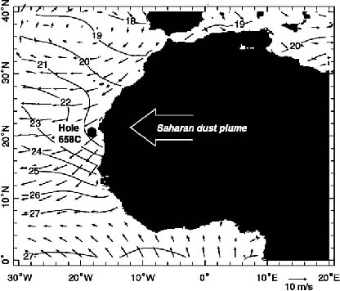
Figure 3 shows the location of ODP 658C relative to the continent of Africa and position of the Saharan dust plume (the wind system that transfers dust from the continent to the ocean). The contour lines reflect sea surface temperatures. This map is taken from the paper by de Menocal et al (2000a)

The aim of this activity is to get you to investigate past changes in the extent of the Sahara desert, one of the world’s most important dryland systems. Attached to this activity is an excel sheet containing data from ODP 658C. This data comes from the work of Peter de Menocal and his colleagues (de Menocal et al. 2000a and b) and is freely downloadable from online archives that house datasets of past climate data. The excel spreadsheet contains two columns. The first of these is age and simply refers to the age (in years before the present day) that samples from the core date to, those closest to the top of the core are the youngest whilst those towards the bottom of the core are the oldest. The second column is titled % Terrigenous. Terrigenous simply means “derived from the land” and this value means how much (as a %) of each sample is made up of dust derived from the land. If the % value is low it means very little of the sediment at that level in the core is made up of wind-blown dust. If the % value is high is means that a lot of the sediment at that level in the core is made up of wind-blown dust. It is these variations between high and low % Terrigenous values that allow us to understand past changes in desert conditions.

As well as getting you to think more deeply and critically about the operation of Drylands over time this activity is also designed to develop your data analysis skills both in terms of working with numerical datasets and interpreting their meaning. Work through the following commands and at the end you should be able to describe and discuss the evolution of the Sahara desert over the past 20,000 years.

- Using the data provided to you in the attached excel spreadsheet produce a line graph using excel with % Terrigenous dust on the x-axis and age on the y-axis (this will show you how Saharan dust transport to the Atlantic ocean varies over time)
- Using the graph that you have produced describe the changes in dust accumulation in the Atlantic ocean over the past 20,000 years.
- If you assume that the amount of dust that is accumulating is proportional to the size and extent of the Sahara desert use the graph that you have produced to describe the history of the Sahara desert over the past 20,000 years. Consider the following points:
A – Over the last 20,000 years how many dry periods, when the Sahara expanded, were there?
B – Over the last 20,000 years how many humid periods, when the Sahara contracted were there?
C – When was the climate in the Sahara at it’s wettest (i.e. when did maximum humidity occur in the Sahara)
D – When was the climate in the Sahara at it’s driest
- Most climate models indicate that deserts such as the Sahara will expand over next few hundred years. If this is the case describe how you might expect this to be recorded in the graph if you could analyse sediments over the next 500 years.

References cited
deMenocal, P.B., Ortiz, J., Guilderson, T., Sarnthein, M., 2000a Coherent High- and Low-Latitude Climate Variability during the Holocene Warm Period. Science, 288 (5474), 2198-2202.

deMenocal, P.B, Ortiz, J., Guilderson, T., Adkins, J.,2000b. Sarnthein, M., Baker, L., and Yarusinski, M. Abrupt onset and termination of the African Humid Period: Rapid climate response to gradual insolation forcing. Quaternary Science Reviews, 19, 347-361.

