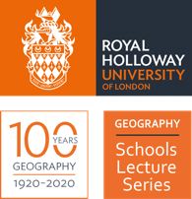
Royal Holloway
Geography for Schools
Lecture Series

Superpower Geopolitics activity
Author: Dr Alasdair Pinkerton

Case study: Mapping the bases of global power

A-Level Syllabus:
- AQA Global systems and global governance
- OCR Global governance – Power & Borders; sovereignty; territorial integrity;

Introduction

- What is a superpower? And why do they matter? — A superpower is country (or countries) with exceptional capacities, especially in terms of their industrial/economic strength and their military capabilities – with a close association between superpower status and those countries which possess nuclear weapons. Superpowers are noted for a particular ability and willingness to project their power and influences well beyond their own borders.

- The concept of “superpower” was developed by the American political scientist, William Fox, in his book The Super-Powers: The United States, Britain, and the Soviet Union (1944) to account for the emergence of countries so powerful that they could wage war on a global scale. The countries he identified as the original “superpowers”—the United States, the United Kingdom and Soviet Union—were the three major countries which, by 1944, were looking increasingly victorious in the prosecution of the Second World War.

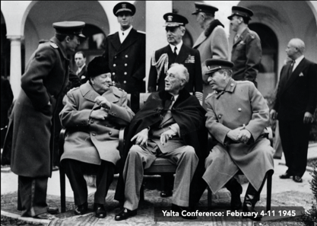
Image 1: The leaders of the three original superpowers at the Yalta Conference (1945)

- Superpowers matters – and not only because they tend to be globally influential but because that influence exposes particular myths about the state of the world:
  - Not all countries are created equal and not all international borders and boundaries and equally respected. If superpowers project their influence beyond their own boundaries, then we must also accept that their influence is felt in other countries, whether willingly or unwillingly.
  - Therefore “sovereignty” is NOT absolute. It’s not something you’ve got, or don’t have.
  - Superpowers (unlike the comic-book figure of superman) are not all hyper-modern, benign and “civilising” agents of change.

- By thinking about superpowers our attention is drawn to the ways in which influence is acquired and sustained in the modern world, while also giving us an insight into the ways that power moves and shifts in response to the rising and falling fortunes of particular countries over time.
  - What about the rise of the BRICS?
  - What about the growing power of non-state actors, including multinational corporations and even terrorist groups?
  - What about issues that are bound up in the acquisition or loss of power? Domination of trade, exploitation of resources, proliferation of nuclear weapons, or responses to global health emergencies?

- The Cold War was a comparatively stable era when two superpowers – the United States and Soviet Union – dominated the global geopolitical scene. They were the predominant powers in terms of:
  - Economic power: they dominated global trade and finance
  - Military power: large conventional arsenals and nuclear powers
  - Political power: their ideologies competed for global attention
  - Cultural power: they used ‘soft power’ to attract people to their causes.

- But, the USA and USSR couldn’t exercise their power in isolation or unilaterally. They belonged to larger collectives, pacts, associations, networks, and trading and security organisations in order to more fully express and exercise their sovereignty, influence and power, including NATO (USA) and the Warsaw Pact (USSR).

- The superpowers didn’t get it all their own way during the Cold War. Their power wasn’t entirely irresistible. The “First World” of the US and its allies, and the ‘Second World” of the Society Union and its allies was challenged by those countries who refused to align themselves in the Cold War. The countries of the Non-Aligned Movement (NAM) – initially Yugoslavia, Egypt, India, Ghana and Indonesia, but which now includes 120+ members – gave rise to the name “Third World”, a term that has become widely associated with less economically developed countries.

*EXERCISE: MAPPING POWER DURING THE COLD WAR*
SEE ATTACHED EXERCISE

- The geopolitical world of the early 21st century has been marked with significant power shifts, at scales above and below that of the nation state, as well as new issues that will reshape power for the centuries to come, including:

  - Rise of the BRICS.
  - Economically and culturally powerful MNCs.
  - Regional economic/political alliances: the EU, Mercosur, NAFTA,
  - Climate and environmental change
  - Challenges to the promise of democracy
  - Demographic shifts and aging populations in the ‘western’ world.

- QUESTION: What other issues do we need to account for when mapping the geometries of shifting power in the early 21st century?

Video resources:

Dr Alasdair Pinkerton. ‘Geography for Schools Lecture: Superpower Geopolitics’
View on Facebook: https://fb.watch/1B8ToaU5qh/
View on YouTube: https://www.youtube.com/watch?v=qkSvGMXs7Ks&t=1848s

Further reading:

Attali, J. ‘China is not the only candidate for a 21st century superpower’, NikkeiAsia (11 June 2020). https://asia.nikkei.com/Opinion/China-is-not-the-only-candidate-for-a-21st-century-superpower
Schuman, M. ‘What Happens When China Leads the World’, The Atlantic (5 Oct 2020). https://www.theatlantic.com/international/archive/2020/10/what-kind-superpower-will-china-be/616580/
Tank, P. ‘The concept of rising powers’, NOREF Policy Brief (June 2012). https://www.files.ethz.ch/isn/146521/aa7c23bf5887ab060f1af737a39a000a.pdf

