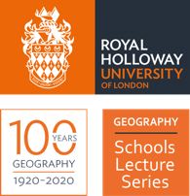
Royal Holloway
Geography for Schools
Lecture Series

Superpower Geopolitics activity
Author: Dr Alasdair Pinkerton

Case study: Mapping the bases of global power

A-Level Syllabus:
- AQA Global systems and global governance
- OCR Global governance – Power & Borders; sovereignty; territorial integrity;

Introduction

By thinking about superpowers our attention is drawn to the ways in which influence is acquired and sustained in the modern world, while also giving us an insight into the ways that power moves and shifts in response to the rising and falling fortunes of particular countries over time.

The concept of “superpower” was developed by the American political scientist, William Fox, in his book The Super-Powers: The United States, Britain, and the Soviet Union (1944) to account for the emergence of countries so powerful that they could wage war on a global scale. The countries he identified as the original “superpowers”—the United States, the United Kingdom and Soviet Union—were the three major countries which, by 1944, were looking increasingly victorious in the prosecution of the Second World War.

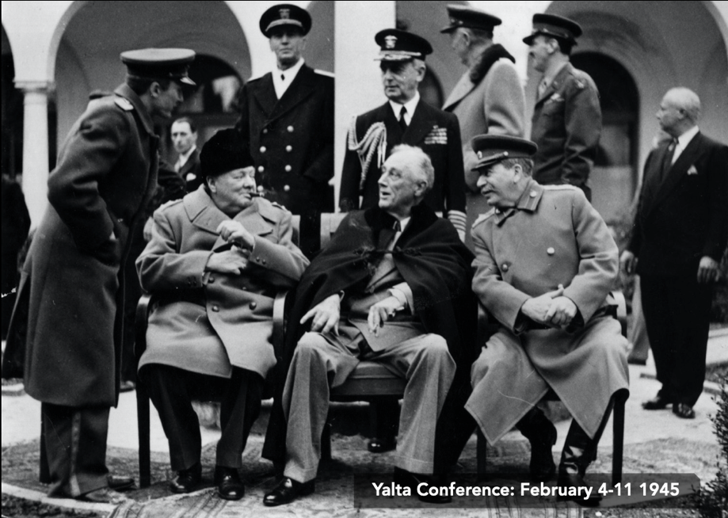
Image 1: The leaders of the three original superpowers at the Yalta Conference (1945)

Very quickly after 1945 the power and influence of the United Kingdom diminished due, in part, to the crippling financial debts it had accumulated during WW2 and then, during the 1950s and 1960s, due to the accelerating process of decolonisation that brought about the end of the British Empire.

This left the United States and the Soviet Union as the two dominant global superpowers. From 1947-1991 the former allies became locked in a manichean (or dualistic) conflict that became known as The Cold War.

*EXERCISE: MAPPING POWER DURING THE COLD WAR*

The United States and the Soviet Union were the dominant global powers and the only two superpowers during the Cold War. Their global dominance can be traced through a number of different types of power.

Using the grids below, record examples of how the United States and Soviet Union maintained their superpower statuses during the Cold War

THE UNITED STATES | MILITARY POWER  (e.g. developed nuclear weapons, formed military alliances) | ECONOMIC POWER
 | POLITICAL POWER | CULTURAL POWER

THE SOVIET UNION | MILITARY POWER | ECONOMIC POWER  (e.g. a centrally planned, industrial economy)
 | POLITICAL POWER | CULTURAL POWER  (Think about: Olympic Games and Chess Tournaments)

Even the most powerful superpowers rarely exercise their power in isolation or unilaterally. They belong to larger collectives, pacts, associations, networks, and trading and security organisations in order to more fully express and exercise their sovereignty, influence and power.

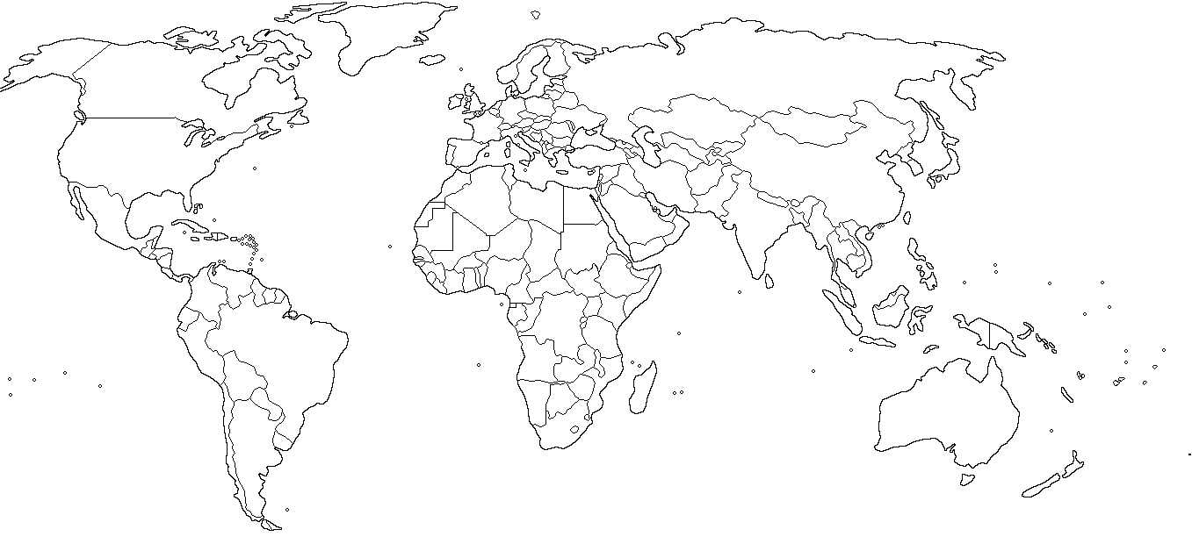

- Use the map and key below to chart the strategic relationships, networks and alliances within which the United States and the Soviet Union operated during the Cold War.
- Begin by mapping the members of NATO and the Warsaw Pact.
- What other pacts/treaty organisations did the US and USSR belong to?

The United States |  |  | The Soviet Union
 | Example: North Atlantic Treaty Organisation (NATO)  (1949-present) |  |  | Example: The Warsaw Pact / Treaty of Friendship  (1955-1991)

- The US and its allies (the “First World”) and the Soviet Union and its allies (the “Second World”) were challenged by a group of countries which formed the Non-Aligned Movement (the Third World). Mark the participants of ‘NAM’ on the map.

Video resources:

Dr Alasdair Pinkerton. ‘Geography for Schools Lecture: Superpower Geopolitics’
View on Facebook: https://fb.watch/1B8ToaU5qh/
View on YouTube: https://www.youtube.com/watch?v=qkSvGMXs7Ks&t=1848s

Further reading:

Attali, J. ‘China is not the only candidate for a 21st century superpower’, NikkeiAsia (11 June 2020). https://asia.nikkei.com/Opinion/China-is-not-the-only-candidate-for-a-21st-century-superpower
Schuman, M. ‘What Happens When China Leads the World’, The Atlantic (5 Oct 2020). https://www.theatlantic.com/international/archive/2020/10/what-kind-superpower-will-china-be/616580/
Tank, P. ‘The concept of rising powers’, NOREF Policy Brief (June 2012). https://www.files.ethz.ch/isn/146521/aa7c23bf5887ab060f1af737a39a000a.pdf

The Cold War: A Story Through Maps
https://www.arcgis.com/apps/MapSeries/index.html?appid=b7b7cdd3cdf8404b92df935d5ee61599

