MEDIA ARTS STYLE GUIDE

Formatting and Style Conventions for Essays and Dissertations

This booklet outlines the basic formatting and style conventions used for written coursework in the Media Arts Department. Do make sure you follow these conventions when submitting all written work.

The booklet is divided into four sections:
1. Page Formatting and Titles
2. Referencing
3. Compiling Bibliographies
4. Filmography
5. Some Common Errors in Written Style

1. PAGE FORMATTING AND TITLES

Basic page formatting:
1. Use margins of approximately 2.5 cm on all sides.
2. Double-space all essays.
3. Always use page numbers.
(The margins and the double-spacing provide space for the marker to add corrections and comments. The page numbers allow the marker to refer to specific passages in their written feedback.)

Film and book titles: Italicise film and book titles. After the first mention of a film include the date and director’s name in brackets, e.g. Psycho (1960, Alfred Hitchcock). Only do this with the first mention of the title.

Titles of essays and articles: The titles of essays and articles should be in inverted commas rather than in italics, e.g. Laura Mulvey’s essay ‘Visual Pleasure and Narrative Cinema’ can be found in her book Visual and Other Pleasures (1989).

Titles of television programmes: Television programme titles should be italicised, but episode titles (where relevant) should be in inverted commas: e.g. CSI, 'Snuff'. Where an individual episode does not have a title (as in episodes of Eastenders or news and magazine programmes) please indicate the transmission date in the form tx. date/month/year: e.g. Channel 4 News, tx. 02/05/09. All programme titles should be followed by year(s) of initial transmission and initial broadcaster: e.g. CSI (2000-, CBS), The Singing Detective (1986, BBC), Buffy the Vampire Slayer (1997-2001, WB; 2001-03, UPN). This information can usually be found on imdb under 'company credits'.

2. REFERENCING

When drawing on, referring to or quoting from the ideas of another writer you must provide a reference using the Harvard referencing system. Failure to refer to secondary sources correctly may lead to charges of plagiarism. If you are in any doubt about plagiarism, ask your teacher or advisor. Universities take plagiarism very seriously.

The Harvard referencing system works through the correlation of a short reference in the text with a bibliographic entry at the end of the essay.
An example of this is given on the facing page, which reproduces a page from Mark Bould’s book Film Noir (2005). Notice how, halfway down the page, Bould follows a quotation with a brief reference identifying its source: (Althusser 1971: 163). This reference corresponds with an entry in the bibliography giving full details of the quotation’s source (see below). Notice how the reference in the text gives us the page number (163) in addition to the author’s surname (Althusser) and the year of publication (1971).
The importance of giving both author and date is evident later on the same page when Bould refers to one of his own publications as Bould 2002. The date distinguishes it in the bibliography from Bould 2003. If two Bould articles from 2003 were cited in the text then they would be identified as Bould 2003a and Bould 2003b.

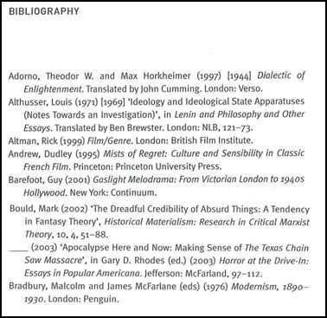

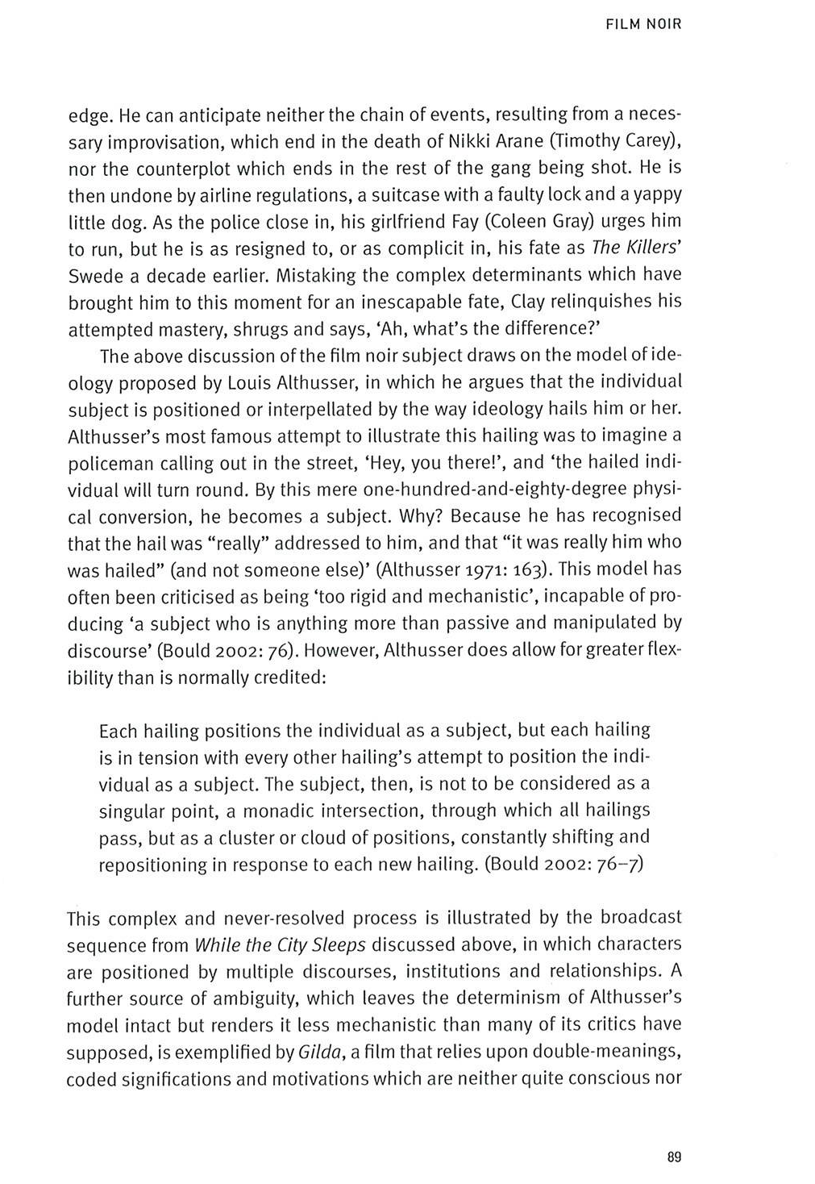
Referencing without quotation: If you are drawing from, paraphrasing or summarising another writer’s work, but NOT quoting directly from them, you must still include a reference to your source. In these cases author and date alone will suffice; page numbers need not be included. For example: ‘Mark Bould (2005) uses Althusser’s ideas about interpellation to investigate the distinctive qualities of film noir.’

Short quotations and long quotations:
(a) Long quotations (more than 40 words) should be set apart from your main text. These quotations should be single-spaced (whereas the rest of your essay should be double-spaced). Long quotations should be indented on the left side by approximately 1 cm. The first line of long quotations should not be indented and the quotation should not be surrounded by quotation marks.
(b) Short quotations (less than 40 words) can be included in the body of the text and should be indicated by single quotation marks (‘…’). Double quotation marks (“ …”) should only be used for quotes within quotes.
(c) As an example of the different formats for short and long quotations contrast the long quote (from Lehman and Luhr) in the middle of the facing page with the shorter quotation (from Ian Cameron) at the bottom of the same page. This is a page from John Gibbs’ Mise-en-Scène (2002).

Where to place the reference: The reference should come at the end of the sentence, before the full stop, unless it is used in a long quotation, in which case the reference comes after the full stop. (For example: again contrast the quote from Cameron with the earlier quote from Lehman and Luhr on the facing page.)

Integrating quotations into your argument: In almost all cases quotations should be formally introduced. That is, rather than just dropping the quotation into the middle of the paragraph and leaving it up to the reference to identify the source, you should introduce the quotation with a phrase such as ‘Mark Bould argues’. An example of this can be seen on the facing page. Notice how, in the sentence before the long quotation, Gibbs identifies the authors and begins to lead us into their argument.

When the author’s name is already included in the passage: If you use the author’s name when introducing a quotation, then that name need not be reproduced in the reference (e.g. see the reference at the end of the long quotation on the facing page).

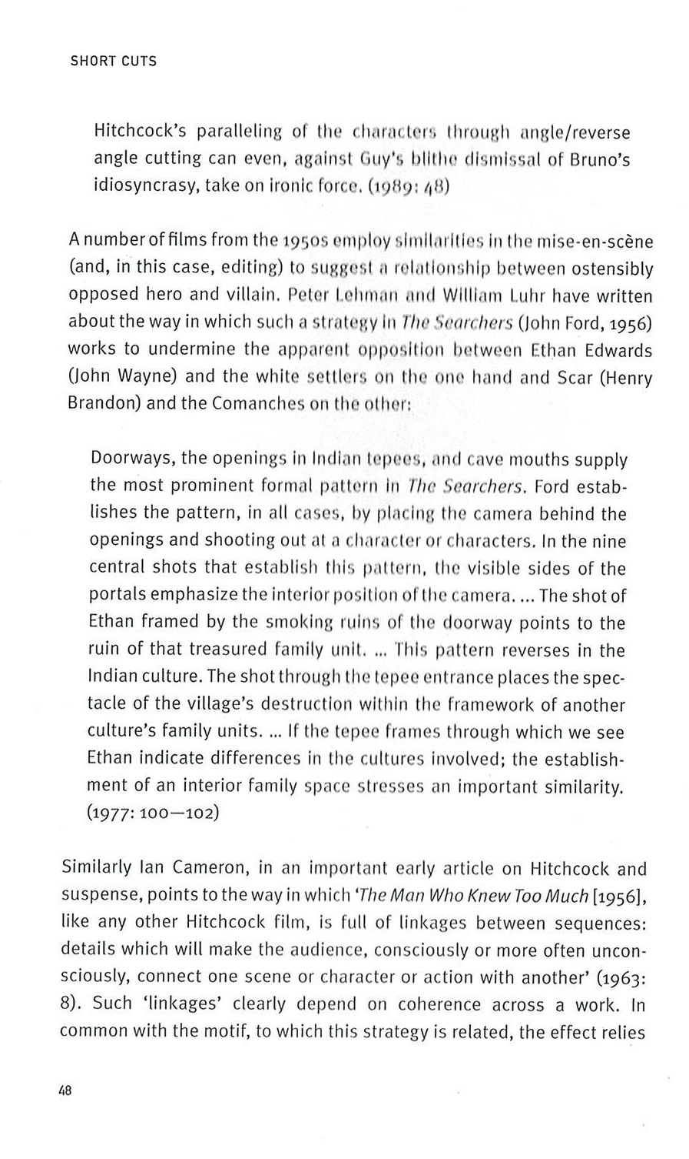

When referring to a source with multiple authors:
Two or three authors: Driver and Rose (1992) argue .....
More than three authors: Benner et al (1996) conclude that ....

Secondary referencing: Secondary referencing is when you refer to the work of a particular author via a secondary source which quotes or discusses that author’s work. In these cases you should cite the primary source and the source you have read. For example, if you wished to refer to the Althusser passage you discovered whilst studying Bould, the reference should read (Althusser 1971: 163; cited in Bould 2005: 89). Secondary referencing should be avoided if at all possible. Try to track down the original source.

References to web articles: You must write a short reference for online sources. Use the same format as for all other references (i.e. author and date), except without the page numbers. (Of course, in those rare cases when online material does use page numbers make sure to include them.) Do not write the full web address within the main text of your essay. Instead, this should be included in you bibliography. (See below for further details on how to write bibliographic entries for web sources.)

3. COMPILING BIBLIOGRAPHIES

You must provide a bibliography at the end of every essay giving details of every source to which you have referred in your essay. Your bibliography must follow the guidelines below. It is best to single-space the text in a bibliography, adding a line between each entry.

A bibliography MUST be in alphabetical order according to surname and it must be unified – that is, you should only have one bibliography, not separate ones for books, essays and websites.

Note: if you are using a number of different essays from the same edited collection then each essay should have its own separate reference and bibliographic entry.

The following examples demonstrate the correct formats for listing bibliographic details.

(A) Single-authored books:

Ardagh, John (1995) France Today. London: Penguin.

Atack, Margaret (1999) May 68 in French Fiction and film. Oxford: Oxford University Press.

Bould, Mark (2005) Film Noir. London: Wallflower Press.

Gibbs, John (2002) Mise-en-Scène. London: Wallflower Press.

(B) Essays and articles in paper journals and newspapers:

Andrew, Dudley (2008) ‘The Ontology of a Fetish’ Film Quarterly 61:4, 62-66.

Andrews, Nigel (1990) ‘Conte de printemps’ Financial Times, 14 June, 21.

Anonymous (1972) ‘The Grand Cartesian’ Time, 9 October, 23.

(C) Essays and chapters in edited collections:

Andrew, Dudley (2004) ‘Adapting Cinema to History: A Revolution in the Making’ in Stam, Robert and Raengo, Alessandra (eds) A Companion to Literature and Film. Oxford: Blackwell, 189-204.

Spiegel, Alan (1981) ‘The Cinematic Text: Rohmer’s The Marquise of O... (1976)’ in Horton, Andrew and Magretta, Joan (eds) Modern European Filmmakers and the Art of Adaptation. New York: Ungar, 313-328.

(D) Articles on websites (the date in brackets at the end is the access date):

Blumenfeld, Samuel (2007) ‘Eric Rohmer: “Je voulais trouver un style moderne”’ Le Monde, 17 May. Available HTTP: http://www.lemonde.fr (30 May 2007).

Ferenzi, Aurélien (2001) ‘Interview with Eric Rohmer’, Senses of Cinema 16. On-line. Available HTTP: www.sensesofcinema.com/contents/01/16/rohmer.html (16 June 2003).

(E) Audio-visual sources:

Barrault, Marie-Christine (1976) Arena, 20 October, BBC TV, [interviewed by Gavin Millar].

Rohmer, Eric (1977) ‘Parlons cinéma [interviewed by André Labarthe and Harry Fischbach]’, tx: TV Ontario, included on La Collectionneuse DVD, Criterion.

Rohmer, Eric (1981) ‘Le cinéma des cinéastes [interviewed by Claude-Jean Philippe]’, tx: France Culture, 22 March 1981, extracts included on La Femme de l’aviateur DVD, Arrow Films.

Scorsese, Martin (2004) ‘Martin Scorsese Interview 2004 Part Three’ from Full Frame Documentary Film Festival, 2004. On-line. Available HTTP: http://www.youtube.com/watch?v=x5K29YGKxcU (27 April 2010).

4. FILMOGRAPHY

When first mentioning a film or TV programme, you will need to include the year and director’s name in brackets after the title (see page three of this document). In addition to this, some essays will also require a filmography, which will list the films, TV programmes or other audio-visual sources as required by the essay and should be placed after the bibliography. The order of the list may be chronological or alphabetical depending on the purpose of the filmography. If your essay requires a more detailed list of audio-visual references, you may find the BUFVC guidelines useful. The BUFVC booklet includes detailed advice about how to refer to a wide range of audio-visual material, including TV programmes, online videos and archive material. If you are unsure whether to include a filmography, ask your course leader.

5. SOME COMMON ERRORS IN WRITTEN STYLE

Your work should be written in an academic style. This is the kind of style you find in the readings set for your work in Media Theory courses. So for example you should not use informal language, slang or abbreviations, such as might be found in casual conversation, electronic mail or text messaging. You should write in complete sentences, which have a grammatical subject and a main verb. So for example these sentences are not complete: ‘Tarantino – what a director! And a pretty good actor.’ Complete sentences would have Tarantino as the grammatical subject, and would have verbs in them, like this: ‘Tarantino is an effective director. He is also an accomplished actor.’

Apostrophes
Apostrophes are used for abbreviation (e.g. couldn’t, wouldn’t) and for indicating the possessive case (e.g. the cat’s pyjamas; Glenda’s cheese). Apostrophes are not used to indicate the plural. Note that, in most cases, abbreviations should not be used in academic writing.

It’s and its
(a) The apostrophe behaves differently when applied to ‘it’. It’s is an abbreviation of it is (e.g. the 1946 film It’s a Wonderful Life). For the possessive, write its (e.g. the cat was happy with its new pyjamas).
(b) The following sentence uses the apostrophe incorrectly: ‘The film was celebrated for it’s innovative sound design.’ The apostrophe is misplaced because in this sentence it’s is not an abbreviation of it is. Instead the sentence should read: ‘The film was celebrated for its innovative sound design.’
(c) Because it’s is an abbreviation it should be used only rarely in academic writing.

Paragraphs
You should write in paragraphs which state a point at the beginning and develop it in the remainder of the paragraph. If your paragraphs look very long (more than about three quarters of a page) you are probably discussing several points which should be dealt with in separate paragraphs. If your paragraphs look very short (just two or three sentences) you are probably not giving proper discussion to the point and you should think again about whether you have developed your idea enough.

It is essential that you redraft your work after writing the first version of your essay. You should look carefully at the development of your argument from paragraph to paragraph, and look at the development and discussion of ideas in each paragraph. Remember the marking criteria value the achievement of a fluid and clear style, and the development of a relevant argument progressively through an essay.

One of the problems which sometimes occurs with written work is a tendency to retell plots, or to explain the feelings and motivations of characters. You can assume that the reader of your essay knows the film, TV programme or other material you are discussing.

You should save the space in your essay for ideas and arguments, rather than informing the reader about aspects of the film which he or she will already know.

If you have trouble with any aspect of essay-writing or presentation, you should ask for guidance from your course tutor or your Personal Advisor. When Department staff hold workshops on academic writing, be sure to attend them.

Further Help
Nigel Warburton’s The Basics of Essay Writing, published by Routledge in 2007, offers a short, informative and accessible guide to essay writing for university students. It is highly recommended.

The University of Oxford Press produces a handbook for all writers and editors. It contains an invaluable section on footnotes and references that is very detailed and will answer virtually all queries about referencing, formatting, titling, etc. It is called New Hart’s Rules and is widely available from bookshops and online booksellers.

